

Briefing Paper on Pricing Reform

Toronto City Summit Alliance: Transportation and Infrastructure Working Group
Contents:
Challenges and opportunities 1
The power of prices 2
Policy initiatives to address the challenges: environmental pricing reform 2
Municipal powers and the City of Toronto Act 4
Sidebar / box - Examples
Kitchener’s Development Cost Charges 1
London’s Congestion Charges 2
Barrie, water pricing - Increasing Block Billing 4
Financing transit and reducing excess automobile use – fuel pricing 5

Challenges and opportunities

Kitchener’s Development Cost Charges

The City of Kitchener has set lower development cost charges for denser types of residential units, and also for development in central neighbourhoods as compared to suburban neighbourhoods. Compared to central charges, suburban charges are 66% higher across all building types. This provides an incentive to build densely and in the central part of town.

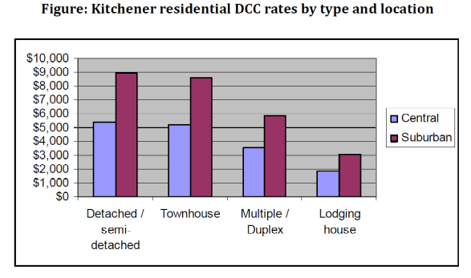

Like other cities, Toronto faces challenges and opportunities on multiple fronts.

Canadian municipalities are heavily dependent on property tax revenues, which unlike income taxes, do not automatically rise with economic growth. Property tax revenues are the single largest source of revenue for Toronto, and constitute nearly half of own-source revenues. As other orders of government address deficits caused by the global recession, municipal governments face constrained or even reduced fiscal transfers, and further downloading of unfunded program responsibilities. The growing recognition of these challenges presents an opportunity to diversify Toronto’s revenue streams.

London’s Congestion Charge

The London Congestion Charge succeeded in changing several indicators from baseline levels. For instance it increased bus usage by 6%, reduced traffic entering the zone by 21%, and raised £137m for investment into transit expansion in 2007/2008 alone.

While tolls are relatively rare in Canada, they are more common in the United States and other countries (see table below).

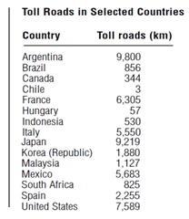
Source: Brown, Hoover, Howatson, Schulman, "Canada’s Transportation Infrastructure Challenge”

Also growing is recognition of the need and opportunity for municipal governments to address long-standing environmental challenges. Sprawl, waste management, traffic congestion, smog and the need to invest in transit are among many pressing issues for Toronto and other municipalities. Again, this growing recognition creates an opportunity for change.

However, in order to know what solutions might be effective, we first need to examine the causes.

The power of prices

Environmental challenges are the result of thousands of economic decisions made every day by firms and individuals. Those involved do not want to cause environmental harm; for the most part they are simply responding to existing price signals; prices often are lower for goods and services that cause environmental harm, and higher for green options. And as long as price signals pull in a brown direction, environmental education, municipal plans and other efforts to protect the environment will fail to fulfill their potential.

The fact that existing price structures can cause environmental harm suggests that they also provide an opportunity to reduce it. There is an opportunity to re-orient the price signals to get them pulling in a green direction. Prices are powerful drivers of behaviour. They can reward and incentivize decisions that benefit the environment, rather than those that harm it. And why should those who want to do the right thing be financially penalized for it?

Orienting market incentives in a green direction is termed Environmental Pricing Reform (EPR). EPR aligns price incentives with other environmental policies. It will enable Toronto to achieve fiscal and environmental goals that it otherwise might never achieve.

Policy initiatives to address the challenges: environmental pricing reform

Price signals can be shifted by EPR policy changes at all levels of government. Municipal governments can employ policy instruments to alter the pricing structure in a wide range of areas, such as:
- Waste disposal – sewage and solid waste
- Transportation – road-use, parking, transit, cycling and pedestrian facilities
- Land use – development, construction, ownership
- Utilities – water and electricity
The following table sets out examples of EPR policy instruments and their incentive effects. For more examples and a fuller discussion, see Smart Budget: A Background Paper on Environmental Pricing Reform for Local Governments.

Policy instrument | Description | Incentive effect
Land-value taxation | Reduce the proportion of property taxation that is attached to improvements (buildings), and increase the proportion attached to land. | Encourage development of brownfield and greyfield sites in urban cores.
Density-based property taxation | Reduce tax rates on properties with high density and/or increase tax rates on properties that are low density. | Encourage higher-density new developments, infill for existing areas.
Improvement districts and tax increment financing | Provide infrastructure and amenities in selected areas, and finance them from property values that are thereby increased. | Encourage development of brownfield and greyfield sites.
Development Cost Charge adjustments | Reduce DCCs on properties that are closer to the urban core or to transit lines and/or increase DCCs far from the core or transit lines. | Reduce sprawl, encourage densification.
Fuel taxes | Levy taxes on transportation fuels, work with other orders of government on sharing revenues. | Increase uptake of transit and other sustainable transportation, and reduce motor vehicle use.
Parking pricing | Selectively decrease and/or increase existing parking prices. Levy parking charges in areas with no charges, e.g. shopping malls. | Shape and reduce motor vehicle use. Level the playing field between downtown businesses and those in malls and suburbs.
Road pricing | Re-allocate road cost financing from general taxes to road use. Toll highways, HOT lanes, cordon pricing, dynamic congestion pricing etc. | Reduce economic losses due to congestion, generate transit financing, diversify revenue sources, reallocate tax burden, reduce motor vehicle use and road maintenance and capital costs.
Unit utility pricing | Re-allocate utility cost financing from general taxes to utility use. Use payments to cover full costs of utility planning, construction, operations, maintenance, repair, decommissioning, replacement, etc. Include lifeline pricing structure and other design features to address regressive impacts and ensure fairness. | Reduce waste, eliminate subsidies, diversify revenue streams. Smart metering (higher prices at peak hours) can defer and reduce peak load and thus need for capacity expansion.
Energy efficiency retrofit financing | Pay capital costs of energy efficiency building retrofits via revolving funds, loans, grants, “on-bill financing” (capital cost is paid back on the utility bill or tax bill). | Reduced energy consumption, lower building-owner costs, increased employment and induced tax revenues.
Subsidy reform | Reduce or remove subsidies that cause environmental harm (e.g. “free” roads) and/or create or increase subsidies that reduce environmental harm (e.g. transit expansion) | Can be tailored to address land-use, utilities consumption, transportation, etc.

Municipal powers and the City of Toronto Act

The ability to use the above-noted policy instruments will vary from province-to-province, depending on municipal powers.

Compared to other municipalities, the City of Toronto is well-positioned to effect EPR. It has relatively broad powers under the City of Toronto Act, notably in relation to the social, economic and environmental well-being of the City and fiscal management.

The Act provides the City with broad general powers (“natural person” powers), which is a much broader approach than the traditional one of providing specific, enumerated powers. Part IX allows the City to levy fees or charges for services it provides. In addition to traditional property tax powers (Part XI), the Act allows it (Part X) to impose direct taxes – like a province does – with a number of exceptions (e.g. income tax, general sales tax, fuel tax, energy tax, poll tax). While the exceptions are significant, again the general inclusion approach gives far greater taxation powers than the traditional enumerative approach.

Barrie water pricing – increasing block billing

The increasing block billing water rate structure is being adopted rapidly across Canada. Between 1991 and 2004, this rate structure rose from 3% to 23% of residential water ratepayers – the fastest increase of any rate structure. Simple or sophisticated progressive structures can be applied, for instance one that ramps up rates at several thresholds of consumption, like an income tax or even continuously as consumption rises (see figure below).

Such a rate structure provides a financial incentive to reduce excessive consumption. Lower rates or rebates for low-income people can also be provided.

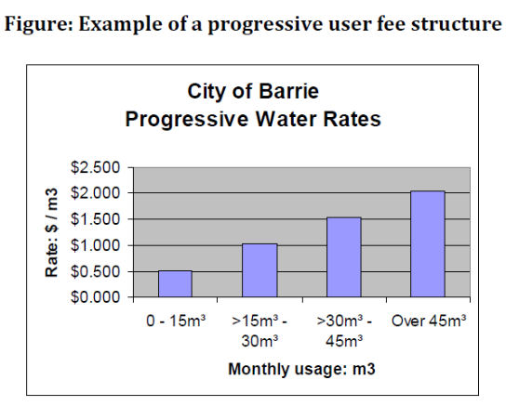

Determining whether a particular policy instrument can be used will require analysis of the specific relevant provisions of the Act. It is possible that one type of instrument that cannot be used (e.g. a specific tax) could be replaced by another type of instrument (e.g. a fee or charge). Or an issue that cannot effectively be addressed directly by price (e.g. heating fuel consumption) can be addressed indirectly (e.g. energy efficiency retrofits).

Determining which policy instruments should be pursued will require further analysis of the fiscal and environmental priorities facing Toronto.

Financing transit and reducing excess automobile use – fuel pricing

Fuel pricing reform has been carried out successfully in many jurisdictions around the world. Increasing revenues by raising existing fuel tax rates can provide badly-needed financing for transit expansion, as well as other public program needs. At the same time, higher motoring prices encourage a shift toward transit use, reduced traffic congestion and lower emissions. European fuel taxes are much higher than those in Canada (see Figure below) and major European cities have lower levels of automobile use and better transit ridership. Indeed North American automobile taxes only cover about 60% of road costs; the remainder of the costs are subsidized by property taxes and other revenue sources.

Many US cities levy fuel taxes directly. In Canada, cities have not had the taxation power to do so. However, this could change. The Federal government has recently made its gas-tax sharing arrangement permanent, and a number of cities receive a share of provincial fuel tax revenues (e.g. Greater Vancouver, Montreal, Victoria Region, Calgary, Edmonton).

Given the expansion in gas-tax transfers to municipalities, and the fact that Toronto is the 6th largest government in Canada, there is a strong argument that the City of Toronto Act should be amended to give Toronto the capacity to directly levy a fuel tax. A regional fuel tax of 6 cents per litre – a small fraction of the annual market price fluctuation – could provide up to $420 million per year in revenues.5

Figure: Fuel tax rates in Canada: significant room for upward movement
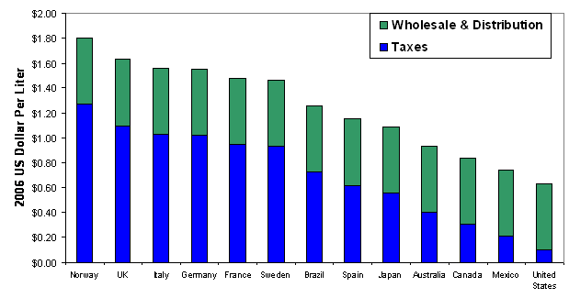
-- Source: Victoria Transportation Policy Institute, "Fuel Taxes: Increasing Fuel Taxes and Fees6

March 31st, 2010 Andrew Bevan and David Thompson
Sustainable Prosperity

.

D.Thompson and A. Bevan, Smart Budget: A Background Paper on Environmental Pricing Reform for Local Governments (Sustainable Prosperity, University of Ottawa, January 2010) http://www.sustainableprosperity.ca/files/Smart_Budget.pdf.
Toronto Hydro is far advanced on installing smart meters and developing Time of Use pricing
City of Toronto Act, 2006, S.O. 2006, Ch.11, Schedule A http://www.e-laws.gov.on.ca/html/statutes/english/elaws_statutes_06c11_e.htm
5 H. Kitchen, "Financing Public Transit and Transportation in the Greater Toronto Area and Hamilton: Future Initiatives" (Residential and Civil Construction Alliance of Ontario, January 2008) p. 24. http://www.rccao.com/news/files/RCCAOFinancingPublicTransitReport01-2008LR.pdf.

